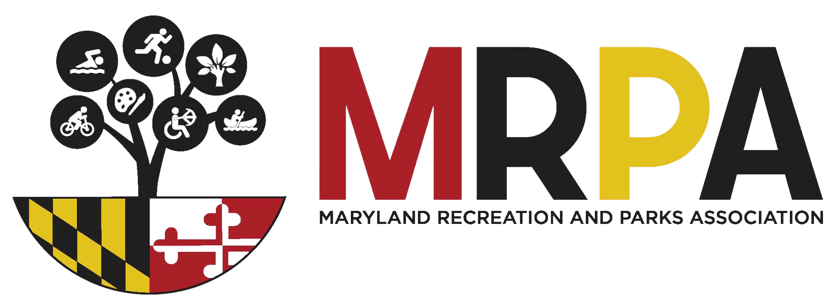
MARYLAND RECREATION AND PARKS ASSOCIATION
CRITERIA & GUIDELINES FOR CONTINUING EDUCATION UNITS (CEUs) Professional Certification Board
Application must be submitted online eight (8) weeks prior to the date of the program. The contact person will receive an email confirmation of the submission. The Professional Certification Board (PCB) will review and provide comments within three (3) weeks of submission.
Programs must be at least one (1) full hour of instruction (contact hour) per unit. For example, two (2) contact hours = .2 CEUs.
If a program is divided into parts, a participant must attend all parts to receive CEUs. Partial credit will not be given.
Speakers cannot earn CEUs for the program they are presenting.
Resumes are required for all presenters and the outline must identify the segments each speaker is presenting. The PCB is responsible for ensuring that the presenter is qualified to speak on the topic.
The maximum number of speakers acceptable per contact hour is four. Panel discussions are not eligible for CEU approval. All approved sessions for CEU credit must be instructional in nature.
If programs approved for CEU credit are repeated, the approval is good for 12 months after the original program. They must have the same speakers, content and time frame. The PCB must be notified via email at least four (4) weeks prior to the repeat program.
Evaluations are a mandatory part of the CEU process. The MRPA office can provide the standard form. Evaluations are to be returned within 30 days of the completion of the program to the MRPA office.
Needs Identification - What is the issue or problem being addressed? Why is this important? Note: This is not what participants will be learning; see Program Objectives.
Program Objectives - Program objectives must be stated in terms of what the learner is expected to accomplish as a result of the learning activity. The objectives should be clear and concise statements of intended learning outcomes. They should specify the knowledge, skills or attitudes learners will acquire relative to the parks and recreation field. Objectives must be observable and measurable. Please reference attached document: Measurable Verbs.
Program Outline - The outline must be detailed with topics and sub-topics. Indicate the time sequence for each topic/activity in the program, and which speaker will be presenting each segment. Any topic/activity over 15 minutes REQUIRES sub-topics with time allotments. Please note that breaks and lunch are not part of the program content. Question and answer period cannot exceed 10 minutes.

